Project Report on
Employee Payroll Management System

RU-100-05-00018
Java for Object Oriented Solutions
SESSION : 2025-26


Submitted by : Angel B M
ERP : RU-25-10189
Bachelor of Computer Application in Association with Google
Under the Guidance of
Mr Harsh Multani Sir

SCHOOL OF INFORMATION TECHNOLOGY
RUNGTA INTERNATIONAL SKILLS UNIVERSITY
BHILAI , CG

(APRIL 2026)

Table of Content

S NO. | Title | Pg no.
1 | Abstract | 5
2 | Introduction | 6
3 | Objectives | 7
4 | Scope | 8
5 | System requirements | 8
6 | Methodology | 9
7 | Flowchart | 9
8 | Implementation | 10
9 | input/output | 11
10 | Future Enhancement | 12
11 | Conclusion | 13
12 | References | 13

CERTIFICATE

This is to certify that the project titled "Employee Payroll Management System"
has been successfully completed by Angel B M , student of BCA (Data Science)
under the guidance of Harsh Multani Sir during the academic year 2025-26.
The work done in this project is original and has been carried out by the student
under proper supervision.

Teacher’s Signature: _____________
HOD Signature: ______________
Date: 15-04-2026

ACKNOWLEDGEMENT

I would like to express my sincere gratitude to Harsh Multani Sir for their valuable guidance, support, and encouragement throughout the completion of this project.
Their clear explanations and suggestions helped me understand the concepts of
Object-Oriented Programming and apply them effectively in this project.
This project has been a great learning experience for me and has improved my
understanding of programming concepts.

Angel B M

Abstract
The Employee Salary Management System is being developed because the organization needs to automate and standardize the payroll process for types of employees. This project is necessary to stop calculation errors and create a digital system that can handle different payment models, such as fixed salaries and hourly wages, all in one place.

This project is an example of using Object-Oriented Programming in Java to solve real financial problems. The system is designed with a class structure that has a base class for all employees, which includes their name and identification number. This allows us to add properties to subclasses easily so the code is easy to understand and maintain. The program uses Inheritance to show the relationship between employee information and specific payment details.

The Employee Salary Management System provides an environment where the salary calculation changes based on the type of employee. For employees with time or flexible contracts the system does not use a fixed salary but instead calculates earnings based on the hours worked and an hourly rate. This is done using Method Overriding, where a method can give results depending on the type of employee.
It makes sure that each type of employee is paid according to their financial parameters resulting in an accurate and professional output. By focusing on code and separating logic the project shows how complex organizational rules can be simplified into a clear and automated process effectively managing the transition, from raw employee data to final salary payments. The Employee Salary Management System is an application that helps with payroll management.

Introduction

The Employee Payroll Management System is a software application designed to manage and calculate employee salaries in an organized and efficient way. In many organizations, handling payroll manually can be time-consuming and errors. This project aims to simplify that process using programming.
This system is developed using Object-Oriented Programming (OOP) concepts in Java. It includes a base class called Employee and specialized classes such as FullTimeEmployee and PartTimeEmployee. Each type of employee has a different method to calculate salary based on their work type.

This project demonstrates important Object Oriented Programming concepts like inheritance, polymorphism, method overriding, and constructor usage (super keyword). It provides a clear structure for managing employee data and calculating salaries using proper logic.
- This system helps in reducing manual work, improving accuracy, and making payroll processing faster and more reliable.
- The system uses an Employee class to keep track of information like names and IDs. This ensures all the data is consistent across the company.
- The system can process a list of employees and apply the correct formula for each one. This makes the work easier.

Objectives

In todays companies, managing payroll for a workforce with different types of jobs is a big challenge. Companies hire people for different kinds of jobs from regular full-time jobs to part-time jobs that pay by the hour. The Employee Salary Management System is a program that uses Java to help with these challenges. It provides a way to calculate salaries that's automatic, reliable and free of mistakes. The main goal of this project is to make it easier to get from the information about an employee to their final paycheck using a structured approach to programming.
This project has technical and functional features like:
- Hierarchical Data Organization: The system uses an Employee class to keep track of common information like names and IDs so all the data is consistent across the company.
- Specialized Compensation Models: The system can handle different ways of paying employees including a base salary plus bonus for full-time staff and an hourly wage for part-time staff.
- Dynamic Logic Execution: The system can process a list of employees and apply the correct formula for each one without needing someone to do it by hand.
- Scalability: The system is designed to be flexible new types of employees like interns or consultants can be added later without changing the existing code much.
This project uses the Java programming language, which's good at supporting object-oriented programming. The project uses ideas like inheritance to reduce repetition in the code. The system is designed to be like a company with a parent class that is always set up correctly and a way to calculate salaries that can be changed for different types of employees. This makes the program a powerful tool, for managing a company, not a simple calculator.

Scope

- Current Suitability:
It helps in the calculation of salaries for employees by providing an accurate method of determining salary and also automatically and accurately calculating bonuses without requiring any complex payroll software.

2. Logical Flexibility:
There are two types of payment models the project supports, Fixed paid salary or salary paid by an hourly basis. These two types of payment models can be used to generate payroll reports.

3. Future Extensions:
The project can be expanded and improved by connecting it to a database, which would allow the user to store thousands of employees employment records.

System requirements :

Hardware : Computer with 4GB RAM
Software : Java JDK, IDE(VS Code /Eclipse)

Methodology
The Employee class is created to store common details like name, id, and base salary. Then, two subclasses FullTimeEmployee and PartTimeEmployee are developed for different types of employees.
After that, salary calculation logic is implemented based on employee type.
Method overriding is used to apply different salary formulas.
Finally, multiple employee objects are created in the main method, and the program calculates and displays their salaries.
Flowchart :
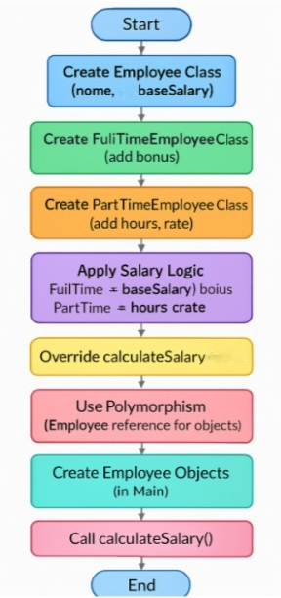

Implementation
The Employee Payroll Management System is made using Javas Object-Oriented Programming.This system is about code reusability and dynamic behavior.It uses things like inheritance and polymorphism to make it work.
- Class Hierarchy and Inheritance:
The system is built on a structure.This means that common properties are put into a Base Class and specific behaviors are defined in Derived Classes.The Employee class is like a blueprint .It has shared data members like name id and base salary.It also has a way to calculate salary that serves as a baseline for classes.The FullTimeEmployee class extends the Employee class.This means it inherits all the properties of the Employee class.It also has a field for bonus, which is like extra corporate benefits.The PartTimeEmployee class also extends the Employee class.It changes the way salary is calculated.
2. Method Overriding:
This is where the calculateSalary method is overridden in both child classes.For FullTimeEmployee the salary is calculated by adding salary and bonus.For PartTimeEmployee the salary is calculated by multiplying hours and rate.This way the program can use the right calculation logic based on the actual object type.
3. Constructor Chaining:
The system uses constructor chaining to make sure that every time a new employee is created the foundational data is handled consistently.This reduces code redundancy. Makes things easier to manage.
4. The Main class demonstrates specialized objects are assigned to Employee type references.The system creates four employee objects with specific data.Then it calls the method for each object.Because of the overriding logic the system automatically selects the formula for each employee.This results in a payroll output, on the terminal.

Input /Output :
(output in terminal)

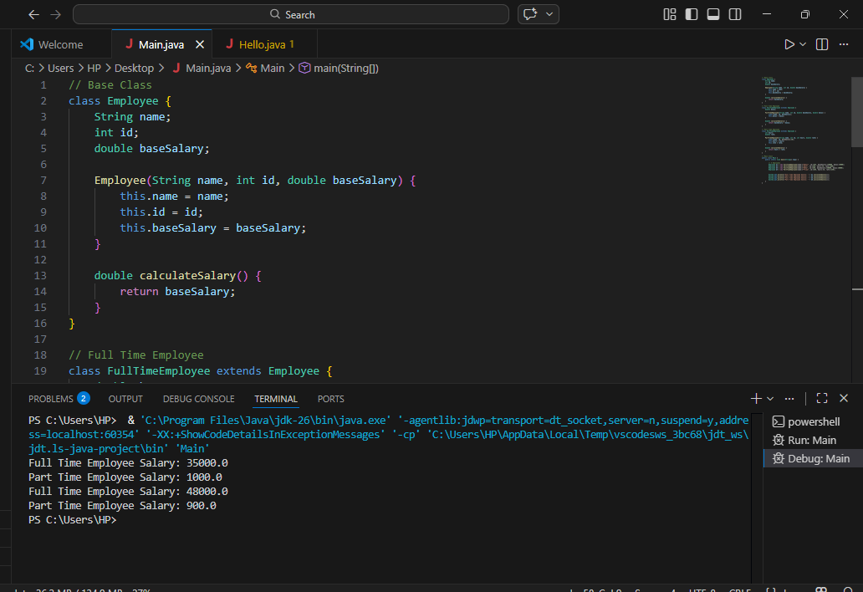

Future Enhancements

The current Employee Payroll Management System is works for simple salary calculation. In the future, several improvements can be made to enhance its functionality and usability.
1. Database Integration:
The system can be connected to a database (like MySQL) to store employee records permanently instead of using temporary data.
2. User Interface:
A graphical user interface (GUI) can be developed to make the system more user-friendly instead of using console-based output.
3. Additional Employee Types:
More employee categories such as ContractEmployee or Intern can be added with different salary calculation methods.
4. Attendance Integration:
The system can be improved by linking attendance data to automatically calculate salary based on working days or hours.
5. Error Handling:
Proper validation and error handling can be added to avoid incorrect inputs and improve system reliability.
6. Report Generation:
The system can be enhanced to generate salary slips or reports for employees.

These improvements will make the system more practical, scalable, and suitable for real-world applications, as suggested in standard Java programming practices.

Conclusion

The project on Employee Payroll Management System demonstrated Object Oriented Programming in Java concepts are Overrriding Method ,Inheritance and Polymorphism and provides a functional system for managing employee payroll.

References
​
Book
Herbert Schildt, Java: The Complete Reference, 11th ed. New York: McGraw-Hill, 2018.
​Website
Oracle, "Java Documentation," Oracle. [Online]. Available: https://docs.oracle.com

